Corey Gaspar
3/21/2026
3-3 Project One Proposal
Goals
The mobile app I’ve chosen to work on is the Event-Tracking App. The app is designed to help users organize and manage events efficiently. The main goal of the app is to make it as simple as possible for users to view their events, add or remove events, and get reminders so they don’t miss their events. The purpose of the app is to keep users organized and make daily planning more efficient.
The app will include a few different components to meet these goals. It will include two tables, one to store the details of the event and one that stores user logins and passwords. The app will also include a screen for logging into the app, and if the user does not have an account, they will be prompted to make one. There will also be a grid that displays all upcoming events. Users will have the ability to add or remove events, change the time and general information of an event, and the user will be notified on the day of the scheduled event.
After logging in, users will be taken to a main screen that displays all upcoming events in a grid or list format. From this screen, users will be able to add or remove events and update the time and general information for each event. When creating an event, users will enter details such as the event name, date, time, and description. In addition, the app will include a notification system that alerts users on the day an event is scheduled. These features ensure that the application meets the requirements outlined in the scenario while also providing a simple and user-friendly experience.
Users
The Event-Tracking App is designed for a variety of users that need a simple way to manage their schedules. One type of user is busy professionals who need to track meetings, deadlines, and other appointments. They would use the app to receive reminders, check their daily schedule, and ensure that they don’t miss any important events. Another type of user is students, who need to organize class schedules, assignment due dates, and activities happening on campus. They can also use the calendar to schedule some time to study and manage both academic and personal tasks. Another type of user is anybody that needs a simple way to track events. A regular user might need to use the app to remind them of appointments, events, or family events. Overall, the app serves any user that is looking for a simple way to manage their schedule.

UI Design
The Event-Tracking app will include different screens to make it simple and easy for users to use. The first screen would be the login screen. This screen will allow users to log in with an existing account or create a new one if they don’t already have an account. It will include input fields for a username and password, along with a button to submit the information. After logging in, the user will be taken to the main calendar screen, which will display all upcoming events in a grid or list format. It will also include a button to add a new event and an option to delete events. This allows users to easily view and manage their events all in one place.
When the user selects the option to add an event, they will be taken to the add event screen. On this screen, the user can enter details such as the event name, date, time, and description. After saving the event, the user will be redirected back to the main screen and the new event will appear. Users can also tap on an event in the main calendar screen, which will open up the event details screen. This screen will display all information about the selected event and will allow the user to update or delete it if needed.
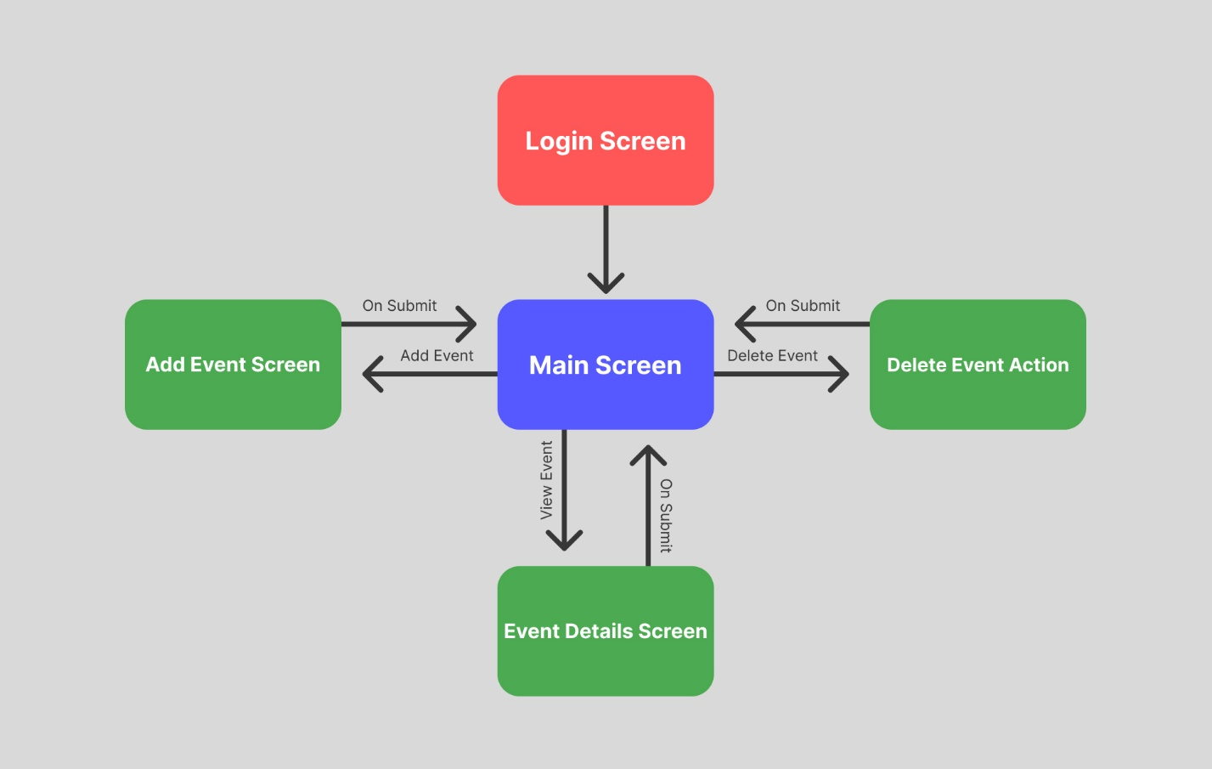
Code Design
The Event-Tracking App will connect the user interface (UI) to a database with two tables: one for user login data and another for event details, such as the event name, date, time, and description. On the login screen, the user will enter their username and password into input fields. When the login button is pressed, the app will check to see if the account exists and if it doesn’t, it will automatically create an account for the user. Once logged in, the app will retrieve the user’s events from the other table if any exist.
The main calendar screen will display any event data created by the user from the table. When a user adds, edits, or deletes an event, the app updates the database and returns to the main calendar screen. On the add event screen, users will enter the event details into input fields. When the save button is pressed, the app will send that data back to the table and it will return to the main screen. On the event details screen, the app displays the selected event’s information and allows the user to update or delete it, which will modify the data for that event in the table.

